Front Page
Make your reservations for July 4th Celebration
2:00 pm – 7:00 pm
Menu
Pulled Pork, Slow Cooked BBQ, Hot Dogs, Hamburgers,
Grilled Barbecue Chicken, Beef Ribs, Baked Beans,
Roasted Potatoes, Corn on the Cob, Steamed Summer Vegetables,
Salad Bar with Assorted Toppings, sliced Watermelon,
Southern Style Strawberry & Blueberry Shortcake
$18++ pp $9++ pp Children 4-12
Children 3 and under free

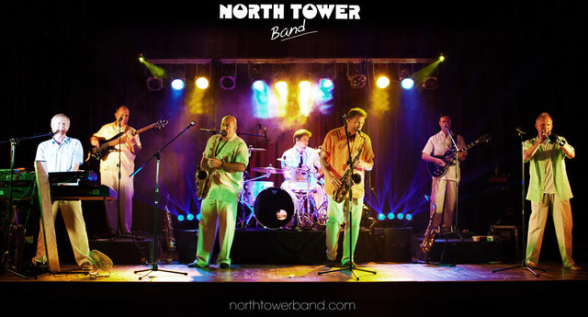
Dance Club Event
Thursday, July 20, Dancing 7-10:00 pm
Buffet Available 5:30 to 7:30 pm
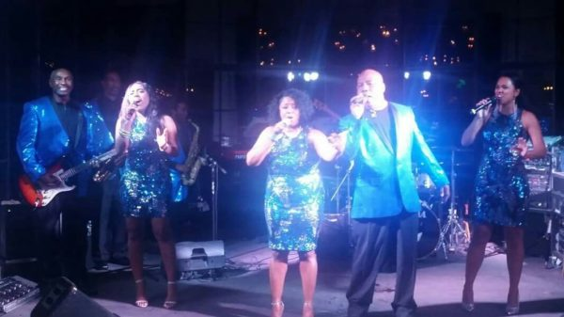
Dance Club Event
Thursday, August 20, Dancing 7 – 10:00 pm
Buffet Available 5:30 – 7:30 pm

Water Exercise on a Noodle
Monday, Wednesday, Friday at 10:30 am
Beginning June 19

July Events
Tuesday, July 4 Celebration
2-7:00 pm
Pool Open 10:00 to 8:00

Friday, July 14
IKE at the pool 5:30 to 7:30 pm

Tuesday, July 18
Bingo/Buffet at the Pool
5:00 pm
Thursday, July 20
Dance Club Event – The North Tower Band
7 – 10 pm
Buffet Available 5:30 to 7:30 pm

Thursday, July 27
Prime Rib Night

August Events
Friday, August 4
IKE at the Pool 5:30 – 7:30 pm

Monday, August 7
Family Buffet at the Pool – 5:00 pm

Tuesday, August 15
Bingo/Buffet at the Pool
5:00 pm
Thursday, August 17
Dance Club Event – Liquid Pleasure
7-10:00 pm
Buffet Available 5:30 – 7:30 pm

August 24
Oyster Night
½ Dozen or Dozen Fresh Oysters
Grilled, Steamed, or Raw
Served with Cole Slaw and Boiled New Potatoes
Market Price

Thursday, August 31
Hamlet Wine Dinner

Friday, August 25
Back to School BASH
“Pool Party” 5 – 8:00 PM
Games, Swimming, and Music

Upcoming Events
B & B
(Burgers and Brew)
Sundays
11:00 am – 7:00 pm
Enjoy our delicious clubhouse burger
with your favorite draft beer
½ price

Children’s Halloween Party
Pumpkin Carving, Crafts, and Games

Adult Halloween Costume Party
Saturday, October 28, 6 – 10:00 pm

Fashion Show and Dinner
November

